Pivot table tutorial
In this pivot table tutorial, you will learn what a Pivot table is, how they work and how they can benefit you and your business intelligence needs. This pivot table tutorial will explain the features and capabilities of a pivot table in plain English that anyone can understand : We are going to use the Pivot table examples in the sample spreadsheet file "AcmeShirtsCompany.xls". This spreadsheet shows sales data for a fictitious company that sells shirts.
A Pivot table in the simplest form aggregates data by creating a dimension for each field and grouping the same values in a field.
To begin you should know that a Pivot table doesn’t always go by this name. Here is a list of other names in which a Pivot table may be known as:
- Pivot grid
- Pivot cube
- Cube
- Data cube
No matter the name they all do essentially the same thing.

The data in this spreadsheet has 7 columns (fields).
Region: Region where the shirts were sold Category: Shirt for a Boy or a Girl.
Shirt Style: Tee shirt, Golf shirt, and Polo Ship Date: Date when the order was shipped
Units: Nr of units shipped on the Ship Date Price: The price per unit for the shirt.
Cost: The Cost per unit for the shirt.
Figure 1
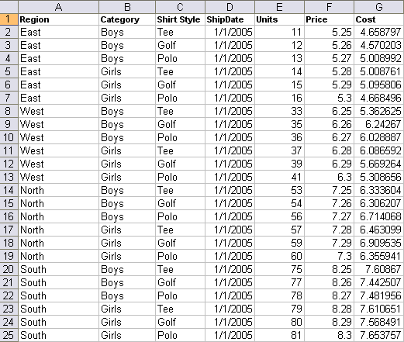

As you can see there is a lot of data here and this is only a subset of the actual spreadsheet. To better understand this data a Pivot table will take each column and create a dimension out of it.
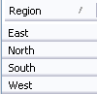
So what is a dimension and how does it work?
In this pivot table example, let’s take the first column; Region. In this column you’ll see there are only 4 different values, East, West, North and South. The Pivot table can take all these rows (25) and condense it down to just the 4 values. Figure 2

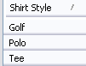
It does this by matching up values and putting them into a group. For example the 6 rows for East have all been consolidated into a single value.
The same is done for Category and Shirt Style
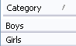
Figure 3 Figure 4
Since this is still confusing, I’ll show you what it looks like in a Pivot Table.
Figure 5
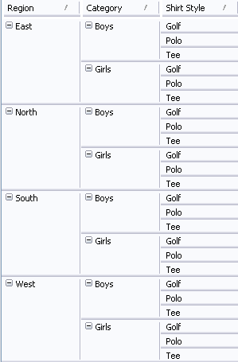
The dimensions in this pivot table example (these were the columns in the spreadsheet) are in the same order as in our sample spreadsheet.
The first thing you probably noticed is that each Region value only appears once and that the Category gets repeated for each Region value and Shirt Style is repeated for each Category. The data is grouped based on the order of the fields. For example, if I change the order of the fields, you’ll see that the values are either consolidated or expanded based on their order.
Figure 6

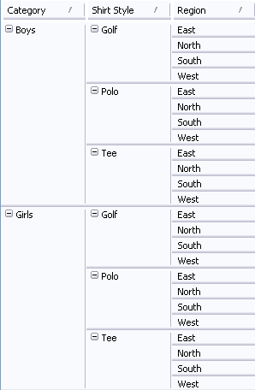
Now each Category value appears once and the Shirt Style is repeated for each Category and Region is repeated for each combination of Category and Shirt Style. The fields are refereed to as a dimension because in a Pivot table they add depth to your data.

Figure 7
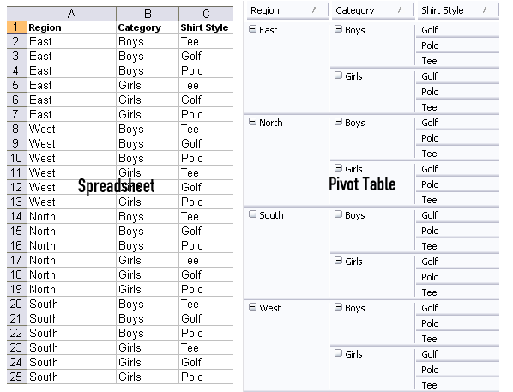
As you can see in this side by side, a Pivot table presents the data in a much cleaner and organized fashion.
You should now have an understanding of what a dimension is and how it works.
What about Ship Date?
I left Ship Date out of the previous pivot table example because it requires a further discussion. Even through the Ship Date is a dimension like Region, Category and Shirt Style it is typically used to aggregate data over time.
Remember the original spreadsheet above had 25 rows and 7 columns? Well the full spreadsheet contains 865 rows and 7 columns. Region, Category and Shirt Style are repeated for each date. The different dates make up the additional rows.
First we’ll add Ship Date to the right of Category in the Pivot table.
Figure 8
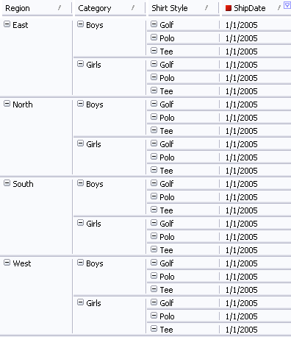
The red square next to Ship Date indicates that all the other dates are filtered out except 1/1/2005. This indicator is not standard to Pivot tables. It is numberGo specific.
The Pivot table is now starting to look a little more like the original spreadsheet minus the Units, Price, and Cost columns.
To demonstrate how the pivoting really works, I’ll need to explain more about the layout of a Pivot table.
Basic components of a Pivot Table
As seen in the pivot table example below there are 3 main parts to a Pivot table.
- Rows
- Columns
- Facts (also known as measures or data fields)
Figure 9
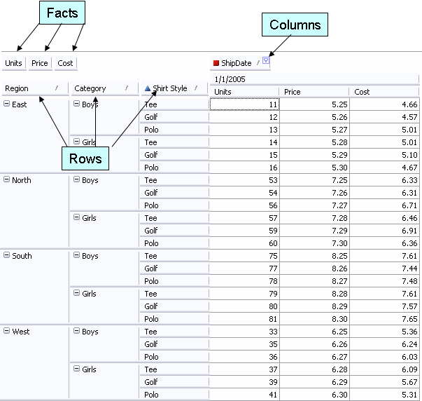
The blue triangle indicator next to Shirt Style means that a custom sort was applied to this dimension. This is not standard to Pivot tables. It is numberGo specific. The dimension was sorted to match the spreadsheet. The default sort is ascending.
The Facts are the numerical dimensions. In the case of our sample data, these are Units, Price and Cost.
The Columns and Rows can be any dimension type. The Row dimensions create a Row for every value and the Column dimension creates a column for every combination of Column fields and Facts. There can be as many columns as you want - more on columns later.
Looks like a spreadsheet; what’s the difference other than the Ship Date being a column?
Now we’ll get into what makes a Pivot table a Pivot table.
All the pivot table examples thus far have been really simple and mimic a spreadsheet so you can understand the basics.
This next image shows a total for each Region and Category along with more dates.
Figure 10
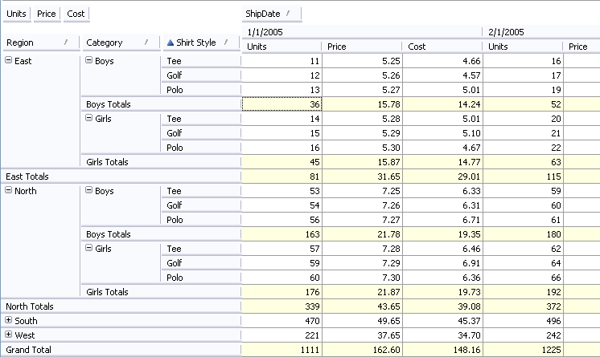
Notice the yellowish rows. These are the totals for East and North and Boys and Girls. The Pivot table automatically sums the rows. The numberGo Publisher provides many more aggregation types such as average, max, min, count, weighted average, error and more. A single dimension can have more than one total line. In many cases you might want to see the Sum and Average.
Also notice that South and West have a + sign to their left. This means the rows were collapsed. You’ll see the single row for South and West displays the sum for each Fact for each Ship Date.
If I remove Category, there are fewer rows because all the rows for each Region are aggregated to the Shirt Style.
Figure 11
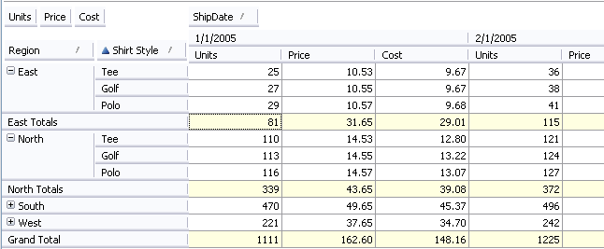
Looking at figure 10 you’ll see that there were 11 Boys Tee shirts sold on 1/1/2005 and 14 Girls Tee shirts sold on 1/1/2005 in the East. In figure 11 Tee shows a totals or 25 sold.
Delving in deeper with numberGo Date Group fields
Even though Date Group fields are not standard to a Pivot table, it’s worth showing because it gives a better understanding of why a Pivot table is so valuable.
numberGo Publisher has the ability to create Date Group fields (or dimensions) from a single basis field.
Take the Ship Date field. You’ll see values such as 1/1/2005, 2/1/2005, 3/1/2005, etc… There are monthly dates for every month from 1/1/2005 – 12/1/2007. By taking this date and slicing it into different parts, numberGo Publisher allows you to create Year, Quarter, Month and Week values along with others down to the second.
Why is this important? Many times you want to see your data rolled up to the year or quarter. In a spreadsheet this would require a lot of work but in Pivot Table (providing you have to proper dimensions), it’s just a click away.
Figure 12
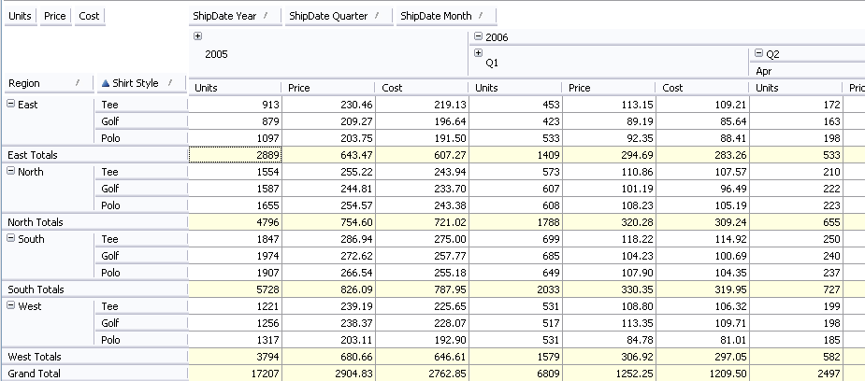
Notice in figure 12 that we now have ShipDate Year, ShipDate Quarter and ShipDate Month. These new fields allow us to easily rollup our numbers they way we want. As seen in figure 12, we get the totals for 2005, the totals for Q1 in 2006 and monthly for Q2 in 2006.
Further Pivoting
So far I’ve kept the Ship Date as a column and the Region, Category and Shirt Style as rows. The next few images of this pivot table example will show different types of Pivots.
Figure 13
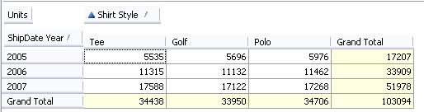
Figure 14
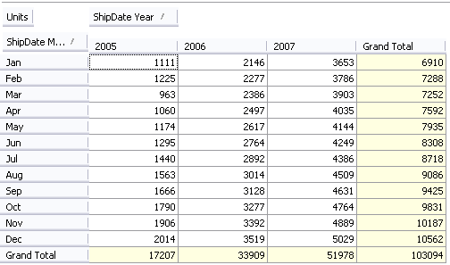
Business Intelligence
As you can see from the pivot table example, being able to pivot and aggregate date in any number of combinations will provide tremendous insight into your business. Totals across time, products, divisions, etc… are all just a few clicks away. No need to create new spreadsheets and formulae to see what’s happening.
Summary
Pivot tables can be used for just about any type of data – sales, financial, shipping, log file analysis and manufacturing just to name a few. Typically any dimension can be in any position except as a fact. Only numeric dimensions can be facts.
A Pivot table is very simple once you understand what to expect.

