PivotTable Magic 09.14.05 By Ben Z. Gottesman

( http://ct.enews.pcmag.com/rd/cts?d=184-2108-5-55-39622-243937-0-0-0-1 )

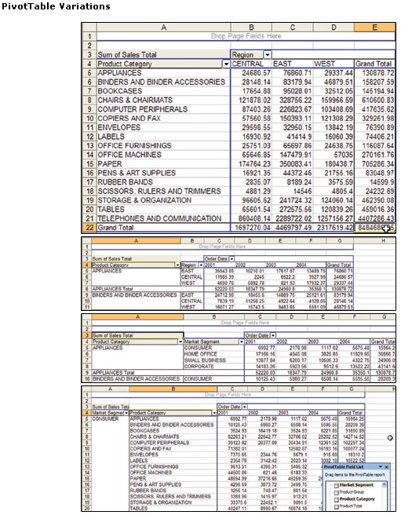
Microsoft Excel's PivotTables give you an amazingly flexible way to analyze your data. PivotTables can take any list in Excel, or the results of a database query, and let you slice and dice the data in almost any imaginable way.

Consider, for instance, our sample data set, which provides detailed sales information for a chain of superstores. By dragging a few fields onto the row, column, and page dimensions of a PivotTable, we can see sales by product category by region. Add and group the Order Date field and move the Region field, and now we can see annual detail. Remove the Region field and insert the Market Segment field, and we now see sales by category across the whole chain, broken down by type of customer. Flip the order of Market Segment and Product Category, and now we see our data by product grouping within customer type. Each change is reflected instantaneously. The possibilities are multitudinous.

It's easy enough to create a PivotTable: Start with a list in Excel, choose Data | PivotTable and PivotChart, and walk through the process with the wizard, specifying what fields should be summarized and where they should be placed. The trick is getting a good feel for what you can actually do with a Pivot-Table. The 14 tips that follow will help you glean much more in-depth information from your data.

Our sample data Excel spreadsheet was provided to us by Tableau Software, whose namesake software lets you create tables of charts for an even deeper look at large data sets. You can download the spreadsheet to try out our tips.

Here are :

Fourteen Ways of Looking at a Spreadsheet

Fourteen Ways of Looking at a Spreadsheet 2
1. - Count Frequency: 3
2. - More than the Sum of All Values: 4
3. - Sort Your Data in Your Order: 4
4. - Sort Your Data Based on Another Field: 5
5. - Filter Your Data by a Specific Value: 5
6. - Filter Your Data by Multiple Specific Values: 6
7. - Filter Your Data Based on Values: 7
8. - Grouping Dates: 8
9. - Grouping Other Data: 9
10. - Turn off AutoFormat: 9
11. - Change How Data Is Presented: 10
12. - What Lies Beneath: 10
13. - Drag That Field Again and Again: 11
14. - The Proper Way to Point: 11

1. - Count Frequency:
Sometimes you want to know how many records in your list contain a certain value in a field, such as how many orders were shipped within each product category. Just drag the field label to the Row drop area, and then drag it again to the Data drop area. If the field contains text values, Excel will count the number of instances of each value.

If it contains numeric values but you want a count instead of a sum, follow the next tip.

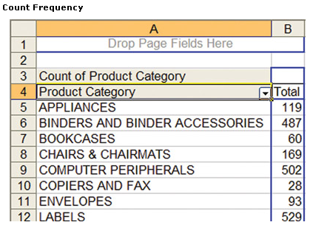

2. - More than the Sum of All Values:
By default, Excel will sum numerical fields placed in the data zone. But you can perform several other operations on them instead. Right-click within the field and choose Field Settings. You can now choose to summarize based on 11 different operations, from averages and counts to standard deviations and variances.

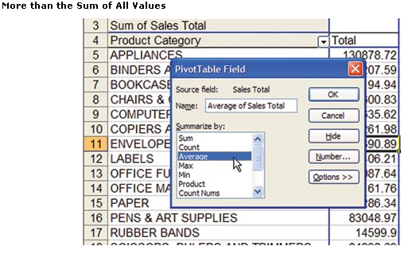

3. - Sort Your Data in Your Order:
By default, Excel sorts your dimensions (rows, columns, and pages) alphabetically (or chronologically, in the case of date/time values). If you want to sort in your own order, such as East, Central, and West, just grab one side of a label and drag it to where you want it. Excel will remember this order.

4. - Sort Your Data Based on Another Field:
To zero in on particular results, you may want to sort your labels based on the values in another field. For example, you can find the best-selling items by sorting product categories based on the sum of the Sales Total field. To do this, double-click the row label for Product Category, which makes the PivotTable field dialog appear. Then you click Advanced, choose Descending under Auto-Sort options, and, from the Using field drop-down list, select Sum of Sales Total. Clicking OK twice gets you back to the table.

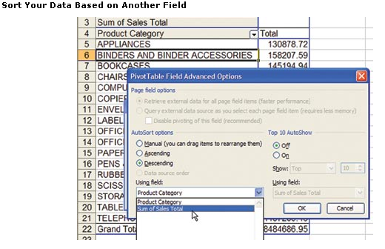

5. - Filter Your Data by a Specific Value:
Excel creates a separate row, column, or page for each unique label in a list. Sometimes you want to look at the values for only one or just a few specific labels. For instance, to look at a specific product category in our table, you would drag the Product -Category field up to the Page area, and then click the drop-down menu next to "(All)" and choose the product category you want to view. (Sometimes it's easier just to type a value rather than selecting it from a list. Don't worry about typos. Excel won't let you enter a value that doesn't exist in the field.)

6. - Filter Your Data by Multiple Specific Values:
To see cumulative results for a few product categories, you'd first have to set the value back to "(All)," then double-click the Product Category label in the Page area. In the PivotTable field dialog that pops up, click on each category in the Hide Items area that you don't want to see. When you click OK to go back to the table, the value "(All)" has changed to "(Multiple Items)" to show that we're looking at a filtered list.
If you want to see a breakout by product category, but only for specific categories, place the Product Category label in the Row area. When a label is in the Row or Column area, the drop-down box lets you select each label you want to look at and removes all the others. As with most things in PivotTables, Excel remembers your settings for filters, even if you drag the field label to different dimensions. If you want to view all data again, don't forget to unhide the records.

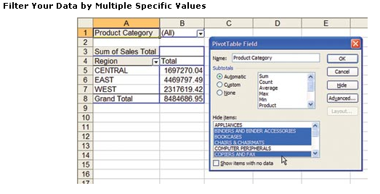

7. - Filter Your Data Based on Values:
If you just want to look at the top performers in a category—for instance, the ten best-selling products—double-click on the field label (Product Category in our case) or right-click and choose Field Settings…, then select the Advanced button. Turn on Top 10 Auto-Show and choose the data field you want to filter on. (Although the feature is called Top 10 AutoShow, you can choose to show anywhere from 1 to 500 top items.)

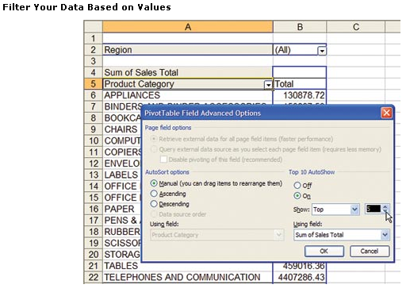

8. - Grouping Dates:
Often your list will have a date field with the specific dates on which transactions occurred. In your analysis, however, you'd probably prefer to summarize information by month, quarter, or year. To do this, drag the date field to a row, column, or page dimension. Right-click within the field or on its label and choose Group and Show Detail and then Group. Excel will sense that it's dealing with date/time data and offer to group it by seconds, minutes, hours, days, months, quarters, and years. You can even select multiple groupings, so you can look at the data by quarter and by year, for instance.

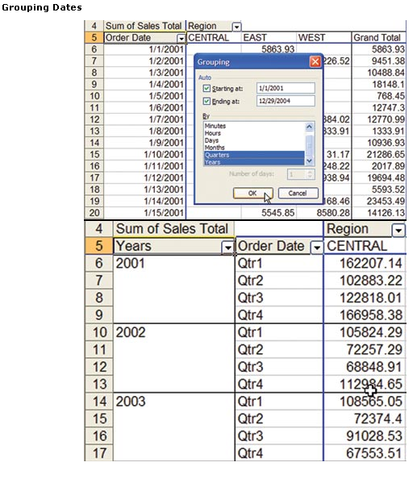

9. - Grouping Other Data:
What if a number of values should be logically grouped, but you don't have a field in your database for those groups? For example, we have region data, but you may want to look at the Mid-Atlantic subregion, grouping Virginia, Maryland, and Delaware together. Start by manually sorting the rows so that related entries are together. Next, highlight those entries, right-click, and select Group and Show Detail and then Group. A new field appears with a label with the number 1 appended to the name (such as States1), and your grouped items are listed as Group1. Repeat these steps for any additional groups you want to create. Then, drag the more detailed data (States) off the PivotTable, and you'll be looking at the data by subregion. Click on the States1 field label and type a more suitable name, such as Subregion, and click on the Group1 label and type Mid-Atlantic.

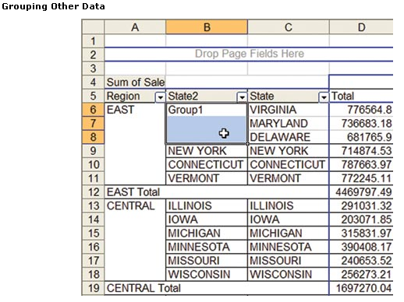

10. - Turn off AutoFormat:
One annoying aspect of PivotTables is that, by default, Excel always resizes the columns so that they're all as wide as the widest column or page label. This often pushes your data way off the page, or makes each column so far from the adjacent ones that it's too difficult to analyze the numbers. To stop this behavior and get control of column widths, click the PivotTable button on the PivotTable toolbar and select Table Options. Deselect AutoFormat Tables.

11. - Change How Data Is Presented:
Sometimes it's more important to know how much each value contributes to the whole than to know the precise value itself. For instance, if you look at the sum of sales by product category, you'll find that the figure for Telephones and Communications is over $4 million. But perhaps what you really want to know is what percentage of the company's total sales that is. To get this value, right-click within the data and choose Field Settings. Next, click the Options button and select Show Data As '% of column'. Click OK to get out of the dialog, and you now see that the telephone-sales proportion is 52 percent of the total. Show Data As offers several other ways to summarize the numbers, including as running totals and as a percentage of some other field.

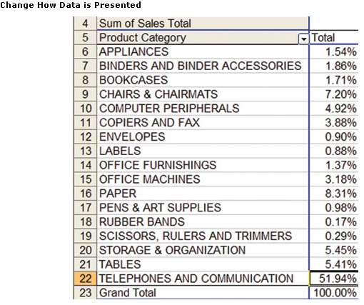

12. - What Lies Beneath:
If you want to see the records that contribute to a specific value, just double-click on that value. Excel will create a new worksheet with these records. The records are not linked back to the table's source, so changes made within them won't be reflected in the table or anywhere else.

13. - Drag That Field Again and Again:
There's nothing restricting you from using a particular field more than once in a table. For instance, perhaps you want to see sales by category both as a dollar amount and as a percentage of total sales. To do this, just drag the same field into the data area twice, showing data first normally, then as a percent of the total.

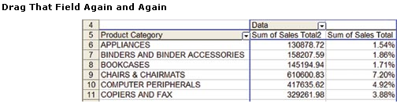

14. - The Proper Way to Point:
If you create a formula with a reference to a cell in a PivotTable, and you add the reference by clicking on that cell, Excel defaults to referring to the cell using the GETPIVOTDATA function, which can be verbose, making the formulas hard to decipher. We generally prefer using just the actual cell reference, B7, rather than =GETPIVOTDATA("Gross Profit",$A$5,"Product Category 2","APPLIANCES").
These are just a few of the tricks you can do with PivotTables to get the most out of your Excel data. Experiment with the options in the right-click menus and all the dialog boxes. Try PivotCharts, a graphical way to look at your data that's only one click away.

